Chapter 17, Problem 59.

The complex Fourier series of the function in Fig. 17.83(a) is

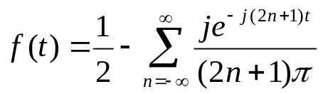, n not equal to zero.

Find the complex Fourier series of the function h(t) in Fig. 17.83(b).

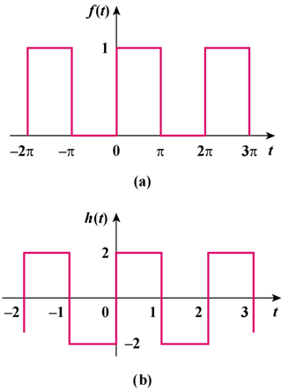

Figure 17.83
For Prob. 17.59.

